

KENDRIYA VIDYALAYA PICKET
COMPUTER SC.
CLASS XII PRACTICAL PROGRAMS
2017-18

CERTIFICATE

This is to certify that Master/Kum.________________
studying in class _________ section________ has completed the Practical’s in the subject of Computer Science(083) for the academic year 201 7-18 in the Senior Computer Lab.
No. of practical’s certified ______________out of ____________ in the subject of Computer Science (083)

………………………….
Teacher In-charge
…………………………
Exam Incharge
…………………
PRINCIPAL
Date …………..
………………….………………….
Institution Rubber Stamp
CLASS XII PRACTICAL PROGRAMS
INDEX
- Multiplication table
- Day of week
- TSA & Volume
- Describe string
- Case shifter
- Display 10 elements
- Display 10 elements in reverse
- Display in matrix form
- Sum of main diagonal elements
- String palindrome
- class STUDENT
- Largest price and sum of prices
- Functioning of ::
- Smallest and largest number
- Multiplication table using random()
- Implementation of function overloading
- Array of structures
- class CLOTHING
- class HOUSING
- Implementation of constructor overloading
- Multi-level inheritance
- Linear search
- Binary search
- Implementation of insertion sort
- Implementation of selection sort
- Implementation of bubble sort
- STACKS using Arrays
- QUEUES using Arrays
- STACKS using Linked lists
- QUEUES using Linked lists
- vowel words
- count no of : vowels, words, digits
- replace ' ' with '#'

1.
/*MULTIPLICATION TABLE*/
#include<iostream.h>
#include<conio.h>
void main()
{
clrscr();
intn,m;
cout<<"\n\tEnter two number (nxm):\n\t";
cin>>n; cout<<"\n\t"; cin>>m;
cout<<"\n\tMULTIPLICATION:";
for(int i=1; i<=m; ++i)
cout<<"\n\t"<<n<<" x "<<i<<" = "<<n*i;
getch();
}
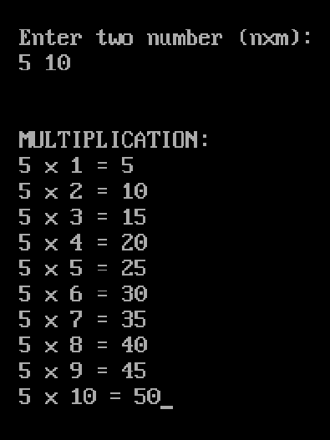
2.
/*DAY OF WEEK*/
#include<iostream.h>
#include<conio.h>
void main()
{
clrscr();
int ch;
cout<<"\n\tEnter day number of a week (Moday=1):\n\t";
cin>>ch; cout<<"\n\t";
switch(ch)
{
case 1:cout<<"MONDAY"; break;
case 2:cout<<"TUESDAY"; break;
case 3:cout<<"WEDNESDAY"; break;
case 4:cout<<"THURSDAY"; break;
case 5:cout<<"FRIDAY"; break;
case 6:cout<<"SATURDAY"; break;
case 7:cout<<"SUNDAY"; break;
getch();
}
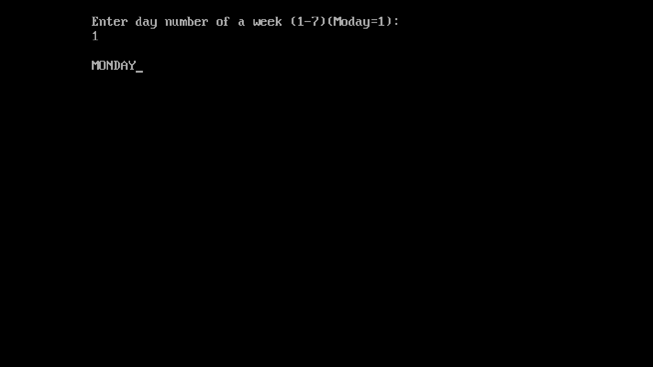
3.
/*TSA & VOLUME*/
#include<iostream.h>
#include<conio.h>
#include<process.h>
#define pi 22.0/7.0
void main()
{
clrscr();
int ch; char ch1;
floatl,b,h;
cout<<"\n\tTSA& VOLUME OF:\n\t1.Cube\n\t2.Cuboid\n\t3.Cylinder\n\t4.Exit"
<<"\n\tEnter your choice:\n\t";
do
{
cin>>ch; cout<<"\n\t";
switch(ch)
{
case 1: cout<<"Enter side:\n\t";
cin>>l;
cout<<"\n\tTSA = "<<6*l*l<<"\n\tVOLUME = "<<l*l*l;
break;
case 2: cout<<"Enter lenght,breadth& height:\n\t";
cin>>l; cout<<"\n\t"; cin>>b; cout<<"\n\t"; cin>>h;
cout<<"\n\tTSA = "<<2*( (l*b) + (b*h) + (h*l))
<<"\n\tVOLUME = "<<l*b*h;
break;
case 3: cout<<"Enter lenght& radius:\n\t";
cin>>l; cout<<"\n\t"; cin>>b;
cout<<"\n\tTSA = "<<2*pi*b*(l+b)<<"\n\tVOLUME = "<<pi*b*b*l;
break;
case 4: cout<<"Breaking"; getch();
exit(0);
default: cout<<"Wrong choice!"; break;
}
cout<<"\n\tWant to enter more (y/n)?\n\t";
cin>>ch1; cout<<"\t";
if(ch1=='y'||ch1=='Y')
cout<<"Enter choice Again (1-4):\n\t";
} while(ch1=='y'||ch1=='Y');
getch();
}
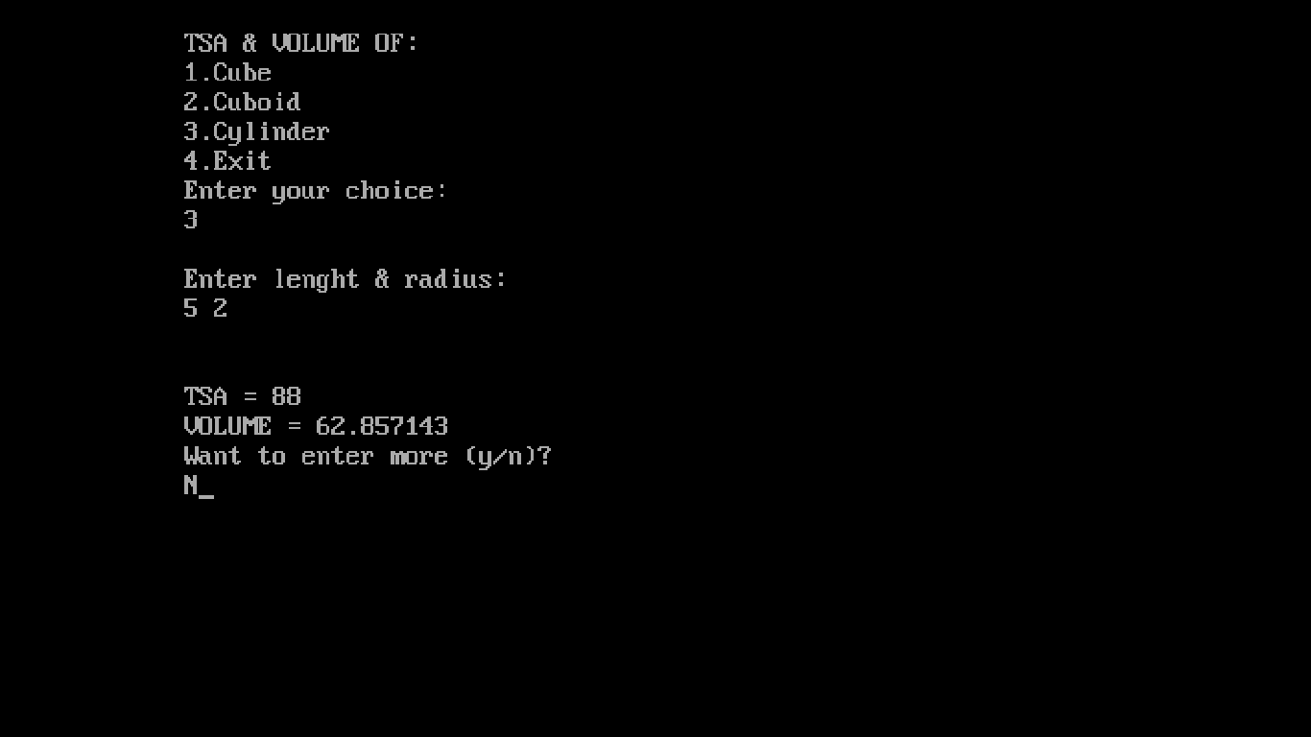
4.
/* DESCRIBE STRING */
#include<iostream.h>
#include<conio.h>
#include<ctype.h>
void main()
{
clrscr();
int a=0,b=0,c=0; char ch[100];
cout<<"\n\tEnter a string:\n\t";
cin.getline(ch,100);
for(int i=0; ch[i]!='\0'; ++i)
if(isupper(ch[i]))
++a;
else if( islower(ch[i]))
++b;
else if( !isalpha(ch[i]))
++c;
cout<<"\n\tNo. of capital alphabets: "<<a
<<"\n\tNo.of small alphabets: "<<b
<<"\n\tNo.of non-alphabets: "<<c;
getch();
}
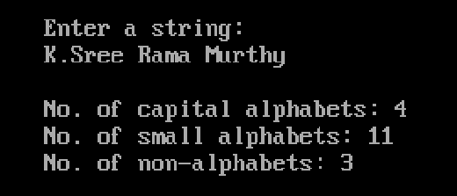
5.
/* CASE SHIFTER */
#include<iostream.h>
#include<conio.h>
#include<ctype.h>
void main()
{
clrscr();

charch[100];
cout<<"\n\tEnter a string:\n\t";
cin.getline(ch,100);
for(int i=0; ch[i]!='\0'; ++i)
{if(isupper(ch[i]))
ch[i]=tolower(ch[i]);
else if(islower(ch[i]))
ch[i]=toupper(ch[i]);
}
cout<<"\n\tUpdated string:\n\t"<<ch;
getch();
}
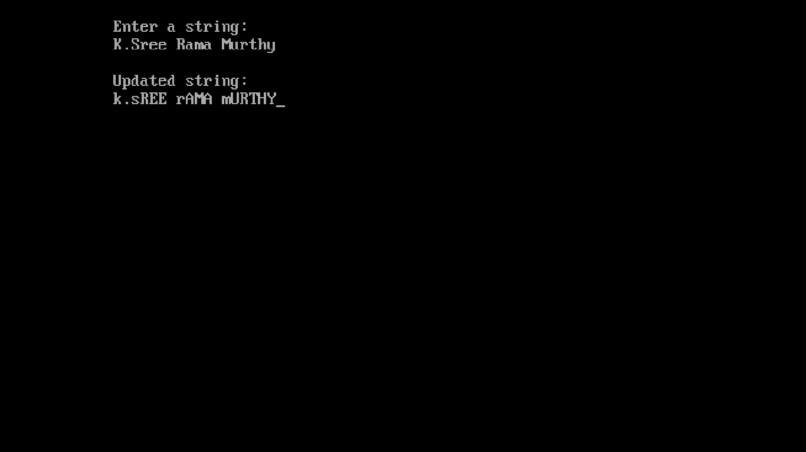
6.
/* DISPLAY 10 ELEMENTS */
#include<iostream.h>
#include<conio.h>
void main()
{
clrscr();
char A[11];
cout<<"\n\tEnter any 10 characters:\n\t";
cin.getline(A,11);
cout<<"\n\tThe 10 characters are:\n\t";
for(int i=0; i<11; ++i)
cout<<A[i]<<" ";
getch();
}
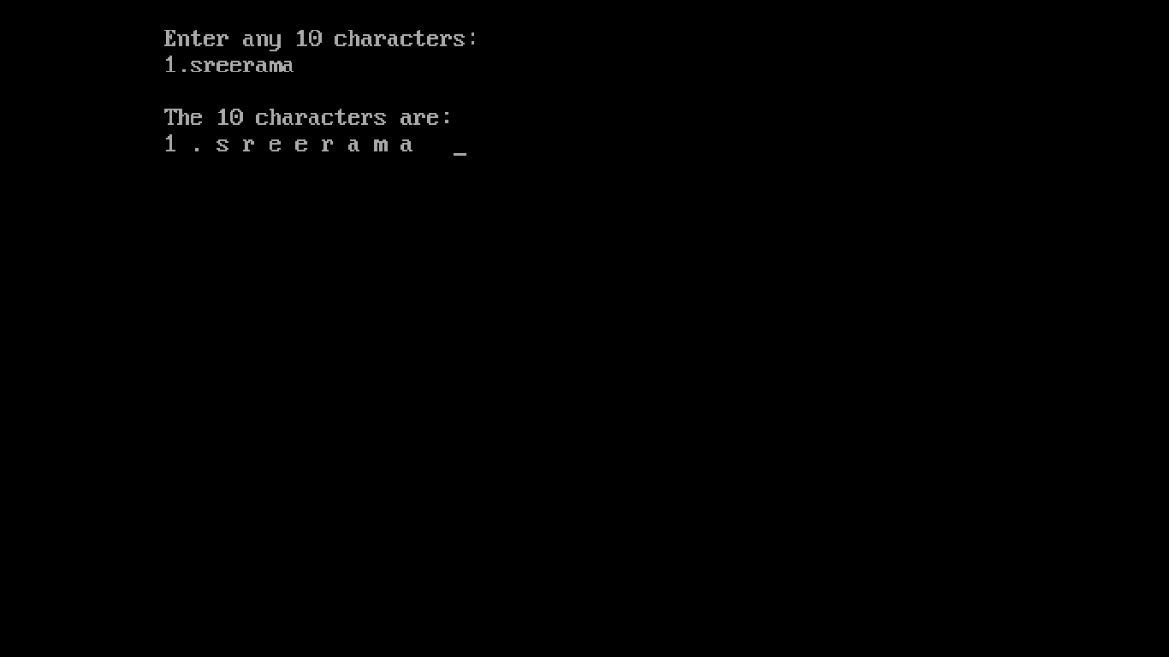

7.
/* DISPLAY 10 ELEMENTS IN REVERSE */
#include<iostream.h>
#include<conio.h>
void main()
{
clrscr();
char A[11];
cout<<"\n\tEnter any 10 characters:\n\t";
cin.getline(A,11);
cout<<"\n\tThe 10 characters are:\n\t";
for(int i=10; i>=0; --i)
cout<<A[i]<<" ";
getch();
}
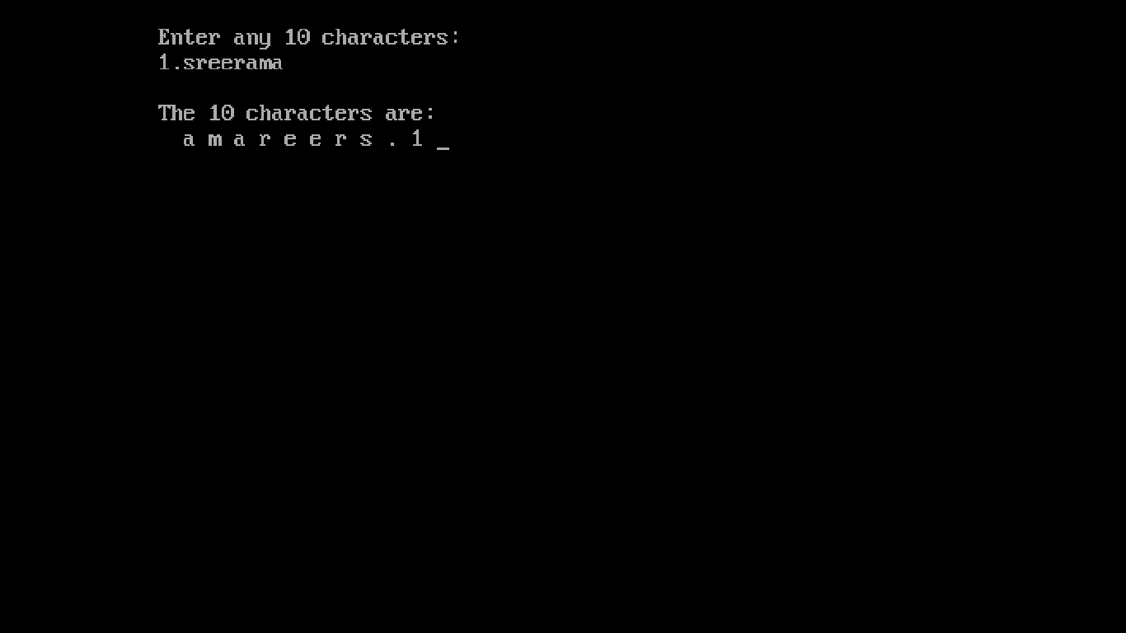

8.
/* DISPLAY IN MATRIX FORM */
#include<iostream.h>
#include<conio.h>
void main()
{
clrscr();
char A[4][10];
cout<<"\n\tEnter 40 characters:\n\t";
for(int i=0; i<4; ++i)
for(int j=0; j<10; ++j)
cin>>A[i][j];
cout<<"\n\tIn Matrix Form:\n\t";
for(i=0; i<4; ++i)
{
for(j=0; j<10; ++j)
cout<<A[i][j]<<" ";
cout<<"\n\t";
}
getch();
}
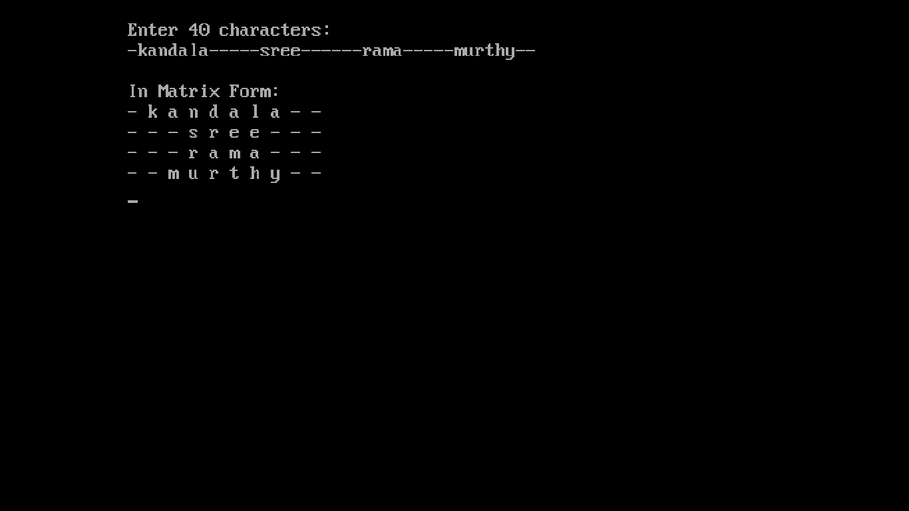
9.
/* SUM OF MAIN DIAGONAL ELEMENTS */
#include<iostream.h>
#include<conio.h>
void main()
{
clrscr();
int A[10][10],i,j,m,sum=0;
cout<<"\n\tEnter size of square 2D array:\n\t";
cin>>m;
cout<<"\n\tEnter Array elements:\n\t";
for(i=0; i<m; ++i)
{
for(j=0; j<m; ++j)
{
cin>>A[i][j];
if(i==j)
sum+=A[i][j];
}
cout<<"\n\t";
}
cout<<"\n\tSum of diagonal elements:\n\t"<<sum;
getch();
}
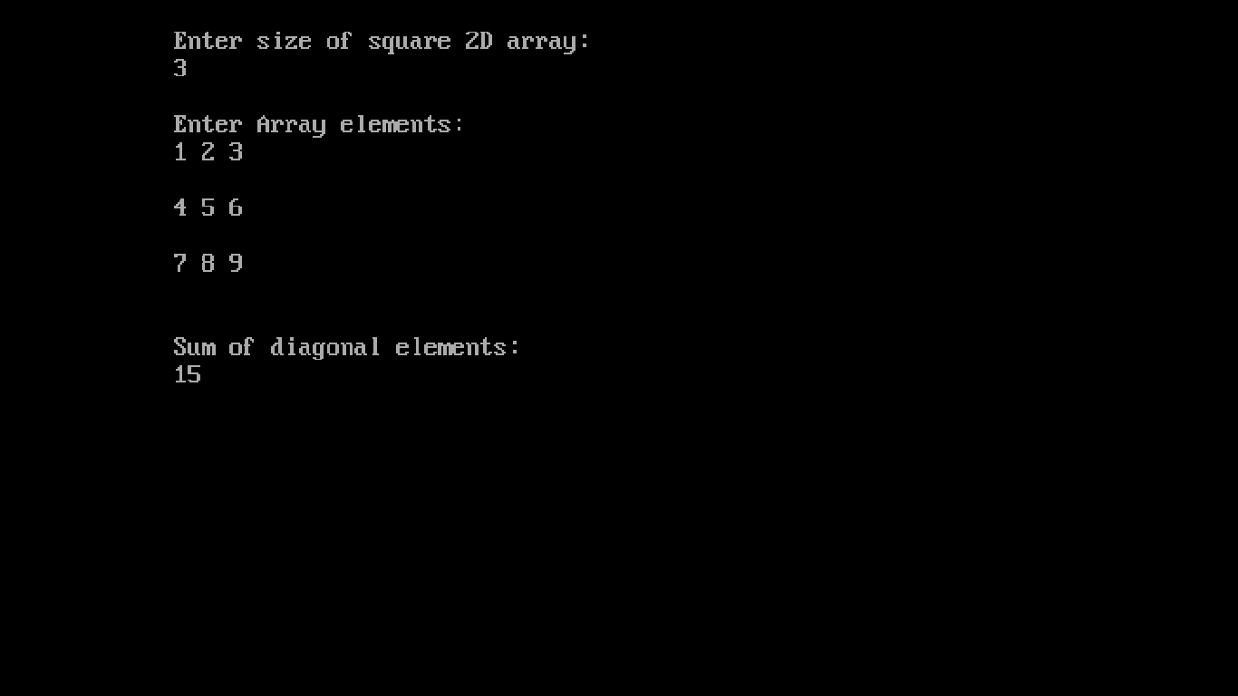
10.
/* STRING PALINDROME */
#include<iostream.h>
#include<conio.h>
Int strpal(char A[])
{
char B[100];
for(int len=0; A[len]!='\0'; ++len);
for(int i=0; A[i]!='\0';++i)
{
B[i]=A[len-1-i];//B is rev of A; len-1 for '\0'
if(B[i]!=A[i])
return 0;
}
return 1;
}
void main()
{
clrscr();
char A[100];
cout<<"\n\tEnter a string:\n\t";
cin.getline(A,100);
if(strpal(A))
cout<<"\n\tIt is PALINDROME";
else
cout<<"\n\tIt is NOT PALINDROME";
getch();
}
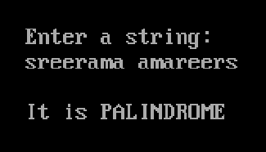
11.
/* class STUDENT */
#include<iostream.h>
#include<conio.h>
#include<string.h>
class STUDENT
{
intRno;
char Name[30],stream[50];
float M[5],avg;
public:
voidAvg();
void read();
void print();
void Stream();
};
void STUDENT::Avg()
{
avg=0;
for(int i=0; i<5; ++i)
avg+=M[i];
avg/=5;
}
void STUDENT::read()
{
cout<<"\n\tEnter Roll NO.,Name& marks in 5 subjects:\n\t";
cin>>Rno; cout<<"\t"; cin>>Name; cout<<"\n\t";
for(int i=0; i<5; ++i)
cin>>M[i];
}
void STUDENT::print()
{
Stream();
cout<<"\n\tRoll NO. : "<<Rno<<"\n\tName : "
<<Name<<"\n\tAverageMarks : "<<avg
<<"\n\tStream : "<<stream;
}
void STUDENT::Stream()
{
Avg();
if(avg>=96)
strcpy(stream,"Computer Science");
else if(avg>=91)
strcpy(stream,"Electronics");
else if(avg>=86)
strcpy(stream,"Mechanical");
else if(avg>=81)
strcpy(stream,"Electrical");
else if(avg>=75)
strcpy(stream,"Chemical");
else if(avg>=71)
strcpy(stream,"Civil");
else
strcpy(stream,"None");
}
void main()
{
clrscr();
STUDENT A;
for(int n=0; n<=20;++n)
{
A.read();
A.print();
}
getch();
}
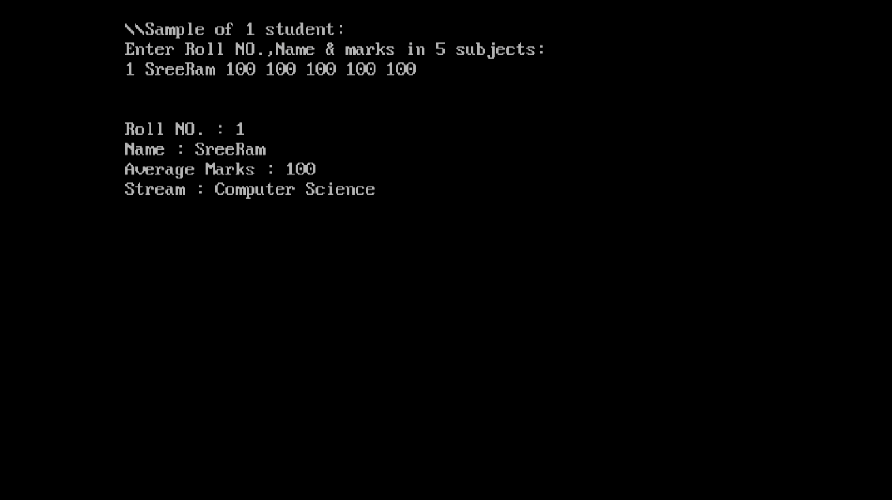

12.
/* Largest price and sum of prices */
#include<iostream.h>
#include<conio.h>

class ITEM
{
int itemcode[50]; float it_price[50];
public:
void initialize(void);
float largest(void);
float sum(void);
void display_items(void);
};
void ITEM::initialize(void)
{
for(int i=0; i<50; ++i)
{
cout<<"\n\tItem No : "<<(i+1)<<"\n\tEnter item code : ";
cin>>itemcode[i];
cout<<"\n\tEnter item price : ";
cin>>it_price[i]; cout<<"\n\t";
}
}
float ITEM::largest(void)
{
float large=it_price[0];
for(int i=1; i<50; ++i)
if(large<it_price[i])
large=it_price[i];
return large;
}
float ITEM::sum(void)
{
float sum=0;
for(int i=0; i<50; ++i)
sum+=it_price[i];
return sum;
}
void ITEM::display_items(void)
{
cout<<"\n\tCode Price : \n\t";
for(int i=0; i<50; ++i)
cout<<"\n\t"<<itemcode[i]<<" "<<it_price[i]<<"\n\t";
}
void main()
{
clrscr();
ITEM order;
order.initialize();
float total, biggest;
int ch=0;
clrscr();
do
{
cout<<"\n\tMain Menu \n\t1.Display largest price "
<<"\n\t2.Display sum of prices \n\t3.Display item list"
<<"\n\tEnter your choice (1-3) : ";
cin>>ch;
switch(ch)
{
case 1: biggest=order.largest();
cout<<"The largest price is "<<biggest<<"\n\t"; break;
case 2: total=order.sum();
cout<<"The sum of prices is "<<total<<"\n\t"; break;
case 3: order.display_items(); break;
default:cout<<"\n\tWrong choice!\n\t"; break;
}
}while(ch>=1&&ch<=3);
getch();
}
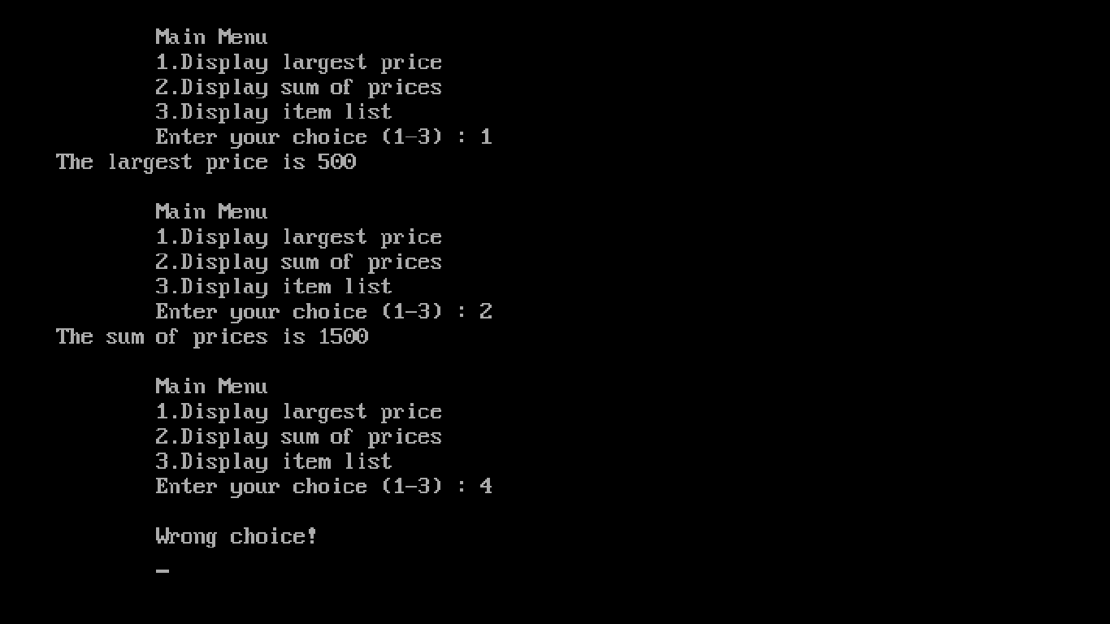
13.
/* Functioning of :: */
#include<iostream.h>
#include<conio.h>

int a=10; //global 'a' with file scope
void main()
{
clrscr();
int a=15; //local 'a' to main()
cout<<"\n\tmain()\n\ta = "<<a<<"\n\t::a = "<<::a<<"\n\t";
{
int a=25; //local to inner block
cout<<"\n\tInner block\n\ta = "<<a<<"::a = "<<::a<<"\n\t";
}
cout<<"\n\tBack to main()\n\ta = "<<a<<"\n\t::a = "<<::a<<"\n\t";
getch();
}
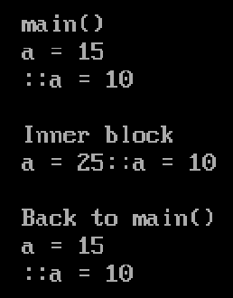
14.
/*program to find the smallest &
largest number in the given list (Array) */

#include<iostream.h>
#include<conio.h>

void main()
{
clrscr();
int A[50],size, min, max;
cout<<"\n\tEnter the number of elements:\n\t";
cin>>size;
cout<<"\n\tEnter the array elements:\n\t";
for(int i=0;i<size;++i)
cin>>A[i];
max=min=A[0];
for(i=0; i<size; ++i)
if(min>A[i])
min=A[i];
else if(max<A[i])
max=A[i];
cout<<"\n\tSmallest number = "<<min<<"\n\tLargest number = "<<max;
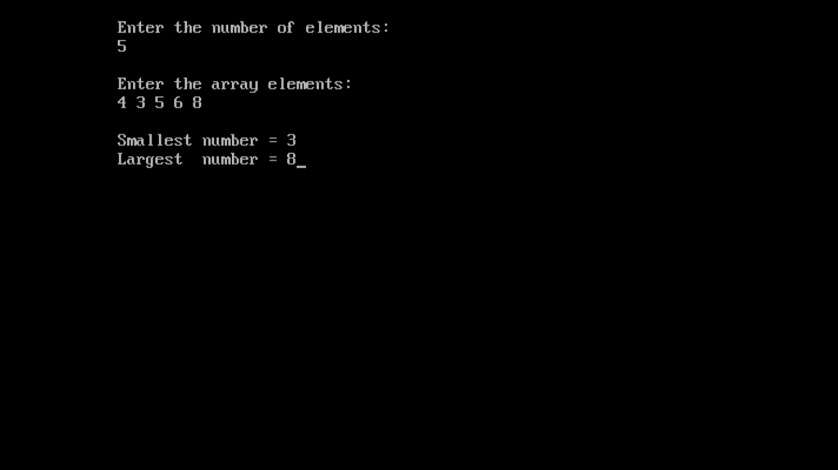
getch();
}

15.
/*MULTIPLICATION TABLE USING RANDOM() */

#include<iostream.h>
#include<conio.h>
#include<stdlib.h>

void main()
{
clrscr();
randomize();
int n=random(20)+1;
cout<<"\n\tmultiplication table of "<<n<<":\n\n\t";
for(int i=1; i<11;++i)
cout<<n<<" * "<<i<<" = "<<n*i<<"\n\t";
getch();
}
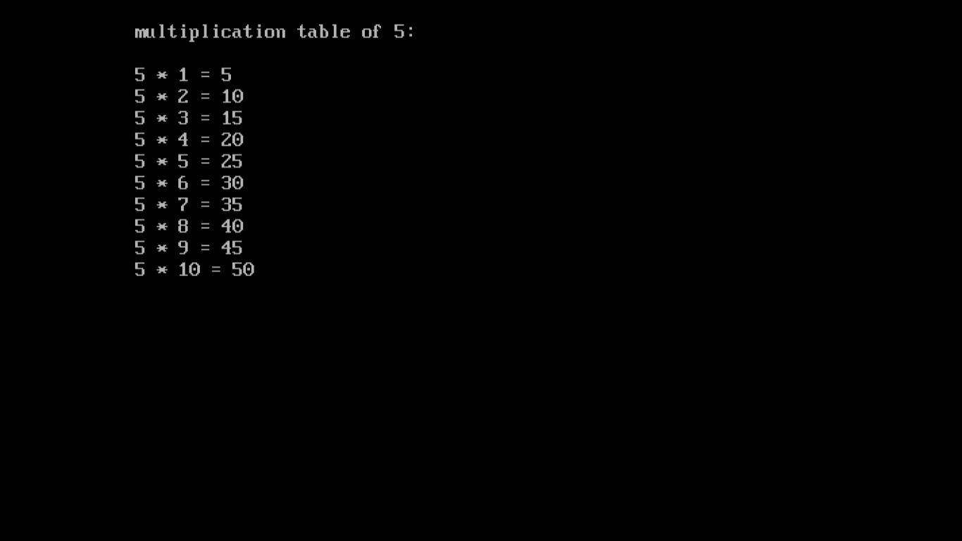
16.
/*IMPLEMENTATION OF FUNCTION OVERLOADING*/
#include<iostream.h>
#include<conio.h>
#include<math.h>

float area(float l,float b) //rectangle
{ return l*b; }
float area(float a) //square
{ return a*a; }
float area(int r) //circle
{ return 3.14*r*r; }
float area(float a,float b,float c) //triangle
{
float s;
s=(a+b+c)/2;
return sqrt( s*(s-a)*(s-b)*(s-c) );
}
int main()
{
clrscr();
float A,a,b,c; int x,ch;
cout<<"\n\tAREA MENU:\n\t1.square\n\t2.rectangle\n\t"
<<"3.circle\n\t4.triangle\n\tEnter your choice: ";
cin>>ch;
switch(ch)
{
case 1: cout<<"\n\tEnter lenght of side:\n\t";
cin>>a;
A=area(a); break;
case 2: cout<<"\n\tEnter lenght of sides:\n\t";
cin>>a>>b;
A=area(a,b); break;
case 3: cout<<"\n\tEnter radius:\n\t";
cin>>x;
A=area(x); break;
case 4: cout<<"\n\tEnter lenght of sides:\n\t";
cin>>a>>b>>c;
A=area(a,b,c); break;
default:cout<<"\n\tWrong choice!"; return 1;
}
cout<<"\n\tArea = "<<A<<” sq.units”;
getch();
return 0;
}
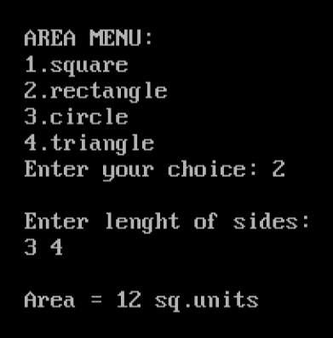

17.
/*IMPLEMENTATION OF ARRAY OF STRUCTURES */
#include<iostream.h>
#include<conio.h>

struct student
{
char name[30];
int roll; float marks[5],tot,per;
};
void main()
{
clrscr();
student S[100];
int n,i,j;
cout<<"\n\tEnter number of students:\n\t";
cin>>n;
for(i=0; i<n;++i)
{
cout<<"\n\tEnter details of student "<<i+1<<"\n\t1.Name: ";
cin>>S[i].name;
cout<<"\n\t2.Roll no.: ";
cin>>S[i].roll;
cout<<"\n\t3.Marks in 5 subjects:\n\t";
S[i].tot=0;
for(j=0;j<5;++j)
{
cin>>S[i].marks[j];
S[i].tot+=S[i].marks[j];
}
S[i].per=S[i].tot/5;
}
getch();
clrscr();
cout<<"\n\tThe student details are:\n\t";
for(i=0;i<n;++i)
{
cout<<"\n\n\tStudent "<<i+1<<"\n\t1.Name : "<<S[i].name<<"\n\t"
<<"2.Roll no. : "<<S[i].roll<<"\n\t3.Marks in 5 subjects :\n\t";
for(j=0;j<5;++j)
cout<<S[i].marks[j]<<" ";
cout<<"\n\t4.Total : "<<S[i].tot<<"\n\t5.Percentage : "<<S[i].per;
}
getch();
}
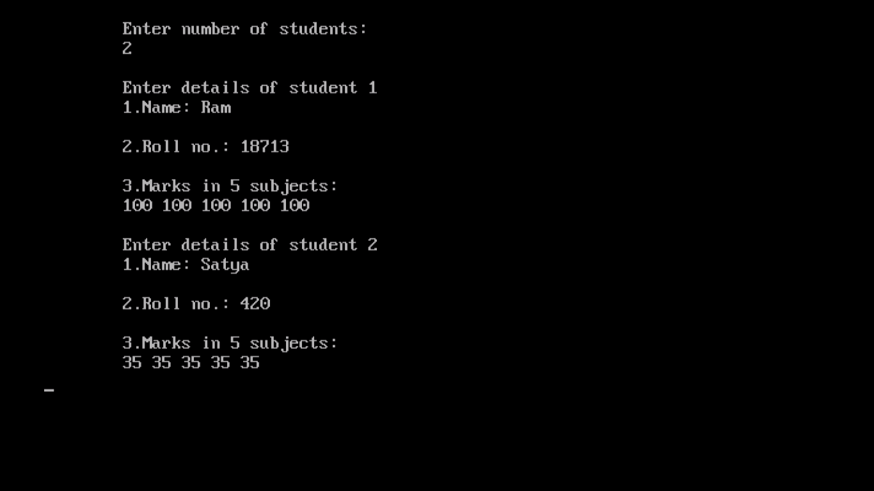

18.
/* class CLOTHING */
#include<iostream.h>
#include<conio.h>
#include<string.h>

class clothing
{
char code[30],type[30],material[30];
int size; float price;
void calc_price();
public:
clothing()
{
strcpy(code,"NOT ASSIGNED");
strcpy(type,"NOT ASSIGNED");
strcpy(material,"NOT ASSIGNED");
size=price=0;
}
void Enter();
void show();
};
void clothing::calc_price()
{
if(strcmpi(material,"COTTON")==0)
{
if(strcmpi(type,"TROUSER")==0)
price=1500;
else if(strcmpi(type,"SHIRT")==0)
price=1200;
}
else
{
if(strcmpi(type,"TROUSER")==0)
price= 1500 - ((25.0/100.0)*1500);
else if(strcmpi(type,"SHIRT")==0)
price= 1200 - ((25.0/100.0)*1200);
}
}
void clothing::Enter()
{
cout<<"\n\tEnter code : "; cin>>code;
cout<<"\n\tEnter type : "; cin>>type;
cout<<"\n\tEnter material : "; cin>>material;
cout<<"\n\tEnter size : "; cin>>size;
calc_price();
}
void clothing::show()
{
cout<<"\n\tcode : "<<code<<"\n\ttype : "<<type
<<"\n\tmaterial : "<<material<<"\n\tsize : "
<<size<<"\n\tprice : "<<price;
}

void main()
{
clrscr();
clothing A;
A.Enter();
A.show();
getch();
}
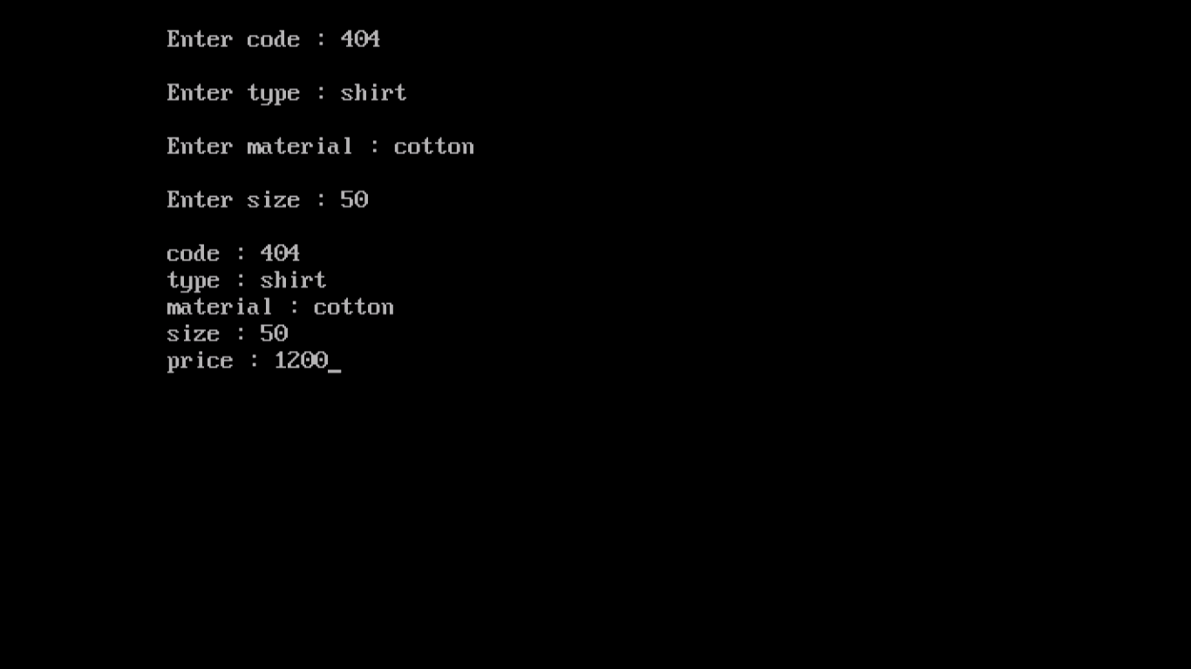

19.
/* class HOUSING */
#include<iostream.h>
#include<conio.h>
#include<stdlib.h>

class HOUSING
{
int reg_no;
char name[30],type[10];
float cost;
public:
void read_data();
void display_data();
void draw_nos();
};
void HOUSING::read_data()
{
cout<<"\n\tEnter name : "; cin>>name;
cout<<"\n\tEnter type : "; cin>>type;
cout<<"\n\tEnter cost : "; cin>>cost;
}
void HOUSING::display_data()
{
cout<<"\n\tName : "<<name<<"\n\tType : "<<type
<<"\n\tCost : "<<cost<<"\n\tRegistration No : "<<reg_no;
}
void HOUSING::draw_nos()
{
randomize();
HOUSING h[10];
for(int i=1; i<11; ++i)
{
cout<<"\n\tHouse "<<i;
h[i].read_data();
h[i].reg_no = random(991)+10;
clrscr();
}
for(int j=0; j<2; ++j)
{
i=random(11)+1;
cout<<"\n\tHouse "<<i;
h[i].display_data();
}
getch();
}

void main()
{
clrscr();
HOUSING A;
A.draw_nos();
getch();
}
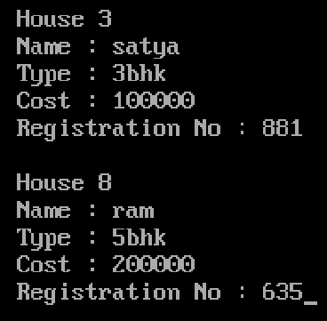

20.
/* IMPLEMENTATION OF
CONSTRUCTOR OVERLOADING */
#include<iostream.h>
#include<conio.h>

class SAMPLE
{
int a; char ch;
public:
SAMPLE() //#1
{ a=0; ch='a'; }
SAMPLE(int x) //#2
{ a=x; ch='a'; }
SAMPLE(char c) //#3
{ ch=c; a=0; }
SAMPLE(int x, char c) //#4
{ a=x; ch=c; }
void display()
{ cout<<a<<","<<ch; }
};
void main()
{
clrscr();
SAMPLE A,B(1),C('b'),D(1,'b');
cout<<"\n\tA : "; A.display();
cout<<"\n\tB : "; B.display();
cout<<"\n\tC : "; C.display();
cout<<"\n\tD : "; D.display();
getch();
}
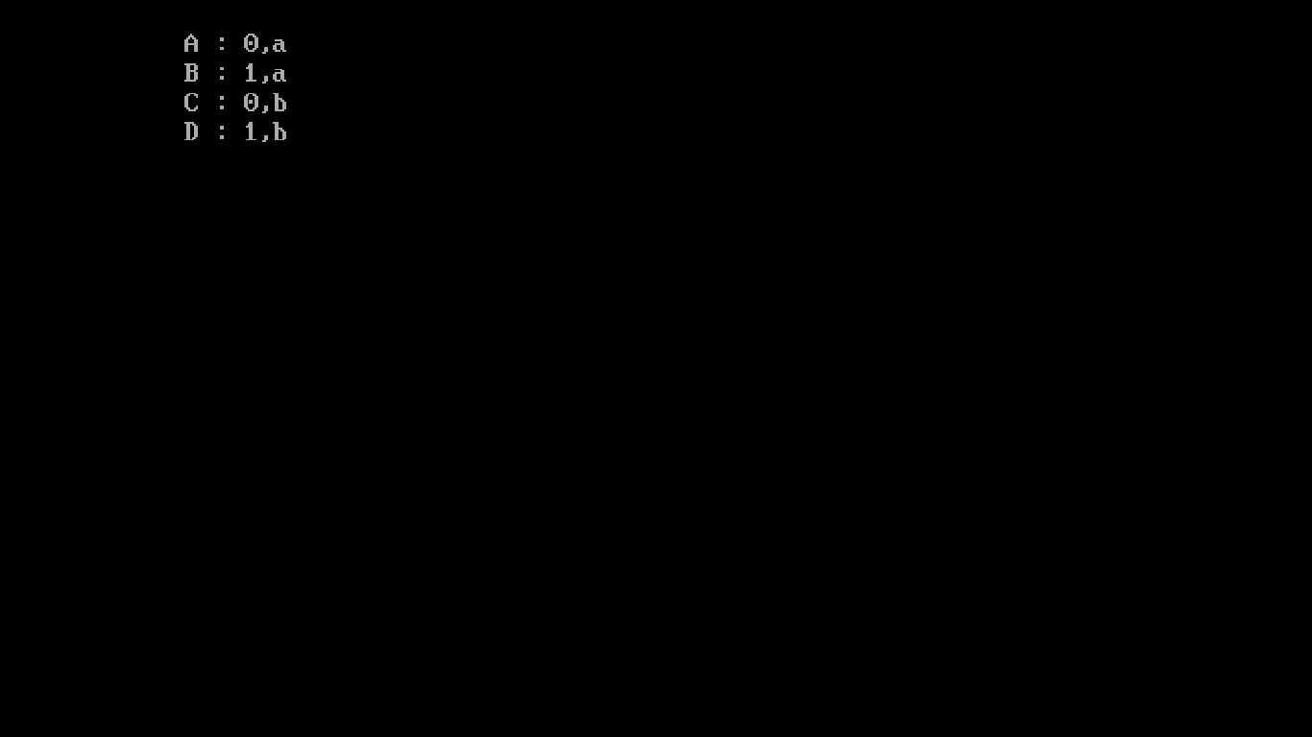
21.
/* Multi level inheritance */
#include<iostream.h>
#include<conio.h>

class SCHOOL
{
int admn;
public:
char name[30];
int ADMN()
{ return admn;}
void read1()
{
cout<<"\n\tEnter name : "; cin>>name;
cout<<"\n\tEnter Admission No : ";cin>>admn;
}
void disp1()
{ cout<<"\n\tName : "<<name<<"\n\tAdmission No : "<<admn; }
};
class CLASS : public SCHOOL
{
int rno;
public:
int RNO()
{ return rno;}
void read2()
{ cout<<"\n\tEnter roll No : "; cin>>rno; }
void disp2()
{ cout<<"\n\tRoll No : "<<rno; }
};
class SECTION : public CLASS
{
char stream[5];
public:
void read3()
{ cout<<"\n\tEnter stream : "; cin>>stream; }
void disp3()
{ cout<<"\n\tStream : "<<stream; }
};
void main()
{
clrscr();
SECTION A;
A.read1(); A.read2(); A.read3();
A.disp1(); A.disp2(); A.disp3();
getch();
}
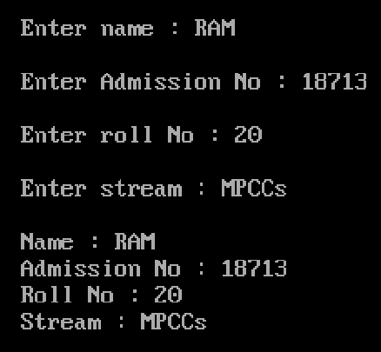
22.
/* LINEAR SEARCH */
#include<iostream.h>
#include<conio.h>

void Lsearch(int A[], int B[], int size, int item, int& count)
{
for(int i=0;i<size;++i)
if(A[i]==item)
{
B[count]=i+1;
count++;
}
}
void main()
{
clrscr();
int i,A[10],B[10],size,item,count=0;
cout<<"\n\tEnter Size of Array : \n\t";
cin>>size;
cout<<"\n\tEnter Array elements : \n\t";
for(i=0;i<size;++i)
cin>>A[i];
cout<<"\n\tEnter element to be searched for : \n\t";
cin>>item;
Lsearch(A,B,size,item,count);
cout<<"\n\t"<<item<<" is found "<<count<<" times at position(s) : \n\t";
if(count)
for(i=0;i<count;++i)
cout<<B[i]<<",";
getch();
}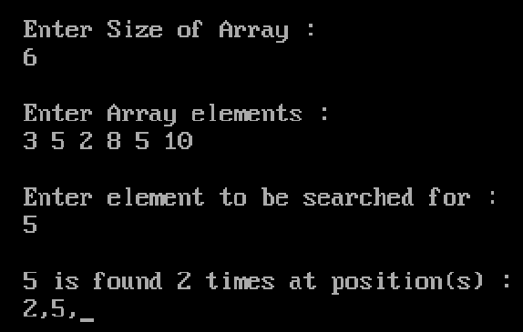
23.
/* BINARY SEARCH */
#include<iostream.h>
#include<conio.h>

int Bsearch(int A[], int size, int item)
{
int beg=0, last=size-1, mid;
while(beg<=last)
{
mid=(beg+last)/2;
if(item==A[mid])
return mid;
else if(item>A[mid])
beg=mid+1;
else
last=mid-1;
}
return -1;
}
void main()
{
clrscr();
int A[10], item, size,pos;
cout<<"\n\tEnter size of array : ";
cin>>size;
cout<<"\n\tEnter array elements : \n\t(must be sorted in Asc order)\n\t";
for(int i=0; i<size;++i)
cin>>A[i];
cout<<"\n\tEnter element to be searched for : ";
cin>>item;
pos=Bsearch(A,size,item)+1;
if(!pos)
cout<<"\n\tElement not found!\n\t";
else
cout<<"\n\tElement found at position "<<pos;
getch();
}
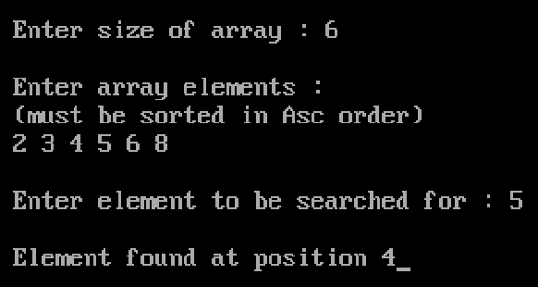
24.
/* Implementation of Insertion sort */
#include<iostream.h>
#include<conio.h>
#include<string.h>

int POS(char A[20][30], char item[30], int size) //to find pos for new element
{
int pos;
if(strcmp(item,A[0]) < 0)
pos=0;
else
{
for(int i=0; i<size-1; ++i)
if(strcmp(A[i],item)<=0 && strcmp(item,A[i+1])<=0)
{ pos=i+1; break; }
if(i==size-1)
pos=size;
}
return pos;
}
int main()
{
clrscr();
char A[20][30], item[30];
int size, pos;
cout<<"\n\tEnter strength of class : ";
cin>>size;
cout<<"\n\tEnter student name list (sorted Asc) : \n\t";
for(int i=0; i<size; ++i)
cin>>A[i];
char ch='y';
while(ch=='y'||ch=='Y')
{
cout<<"\n\tEnter new student name to be inserted : ";
cin>>item;
if(size==20)
{
cout<<"\n\tOverflow!";
return 0;
}
pos=POS(A,item,size);
for(i=size; i>pos;i--)
strcpy(A[i],A[i-1]); //shift elements
strcpy(A[pos],item);
size+=1;
cout<<"\n\tWant to insert more? (y/n) ";
cin>>ch;
}
cout<<"\n\tUpdated student name list : \n\t";
for(i=0; i<size; ++i)
cout<<A[i]<<" ";
getch();
return 0;
}
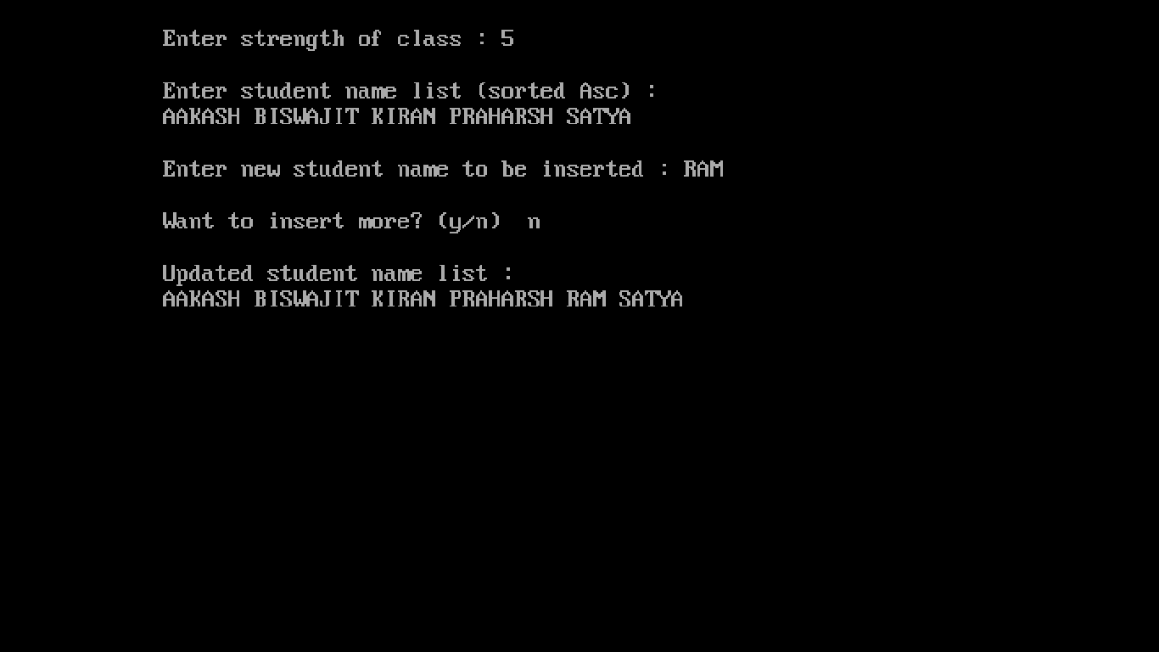
25.
/* Implementation of Selection sort */
#include<iostream.h>
#include<conio.h>
#include<string.h>

void SORT(char A[][30], int size)
{
char small[30], tmp[30]; int pos;
for(int i=0; i<size-1; ++i)
{
strcpy(small,A[i]);
pos=i;
for(int j=i+1;j<size;++j)
if(strcmp(A[j],small)<0)
{ strcpy(small,A[j]); pos=j; }
strcpy(tmp,A[i]);
strcpy(A[i],A[pos]);
strcpy(A[pos],tmp);
cout<<"\n\tArray after pass-"<<i+1<<"-is : ";
for(j=0; j<size; ++j)
cout<<A[j]<<" ";
}
}
void main()
{
clrscr();
char A[20][30]; int size;
cout<<"\n\tEnter strength of class : ";
cin>>size;
cout<<"\n\tEnter student name list : \n\t";
for(int i=0; i<size; ++i)
cin>>A[i];
SORT(A,size);
cout<<"\n\tSorted array : \n\t";
for(i=0; i<size; ++i)
cout<<A[i]<<" ";
getch();
}
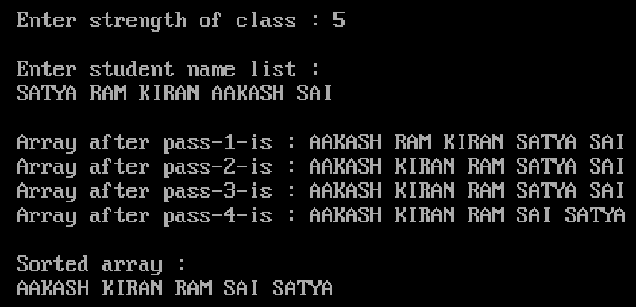
26.
/* Implementation of Bubble sort */
#include<iostream.h>
#include<conio.h>
#include<string.h>

void bubblesort(char A[][30], int size)
{
char tmp[30]; int ctr=0;
for(int i=0; i<size; ++i)
{
for(int j=0; j<(size-1)-i; ++j)
if(strcmp(A[j],A[j+1]) >0 )
{
strcpy(tmp,A[j]);
strcpy(A[j],A[j+1]);
strcpy(A[j+1],tmp);
}
cout<<"\n\tArray after iteration -"<<++ctr<<"- is : ";
for(int k=0; k<size; ++k)
cout<<A[k]<<" ";
cout<<"\n\t";
}
}
void main()
{
clrscr();
char A[20][30], item[30];
int size, pos;
cout<<"\n\tEnter strenght of class : ";
cin>>size;
cout<<"\n\tEnter student name list : \n\t";
for(int i=0; i<size; ++i)
cin>>A[i];
bubblesort(A,size);
cout<<"\n\n\tSorted list : \n\t";
for(i=0; i<size; ++i)
cout<<A[i]<<" ";
getch();
}
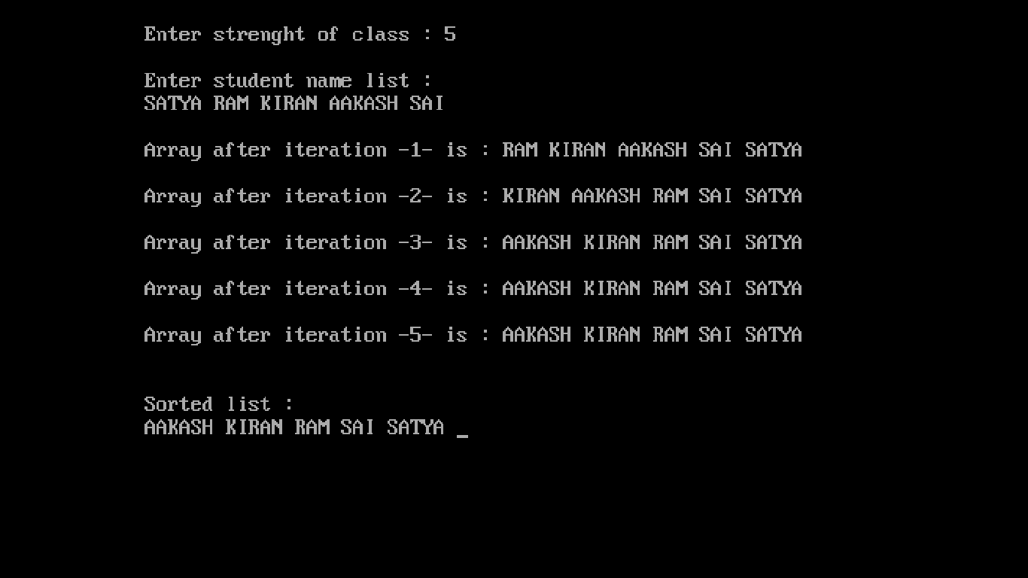

27.
/* Implementation of STACK using arrays */
#include<iostream.h>
#include<conio.h>

class STACKS
{
int STACK[30],top;
public:
STACKS()
{ top=-1; }
void PUSH();
void POP();
void DISPLAY();
}s;
void STACKS::PUSH()
{
int ele;
if(top==30)
cout<<"\n\tstack FULL";
else
{
cout<<"\n\tEnter element : ";
cin>>ele;
STACK[++top]=ele;
}
}
void STACKS::POP()
{
if(top==-1)
cout<<"\n\tStack is empty";
else
cout<<"\n\tElement popped : "<<STACK[top--];
}
void STACKS::DISPLAY()
{
int i;
cout<<"\n\tStack elements : \n\t";
for(i=top;i>=0;i--)
cout<<STACK[i]<<" ";
}
void main()
{
clrscr();
char ch='y';
int choice;
do
{
cout<<"\n\tSTACK OPERATION\n\n\t1.PUSH\n\t2.POP"
<<"\n\t3.DISPLAY\n\tEnter your choice : ";
cin>>choice;
switch(choice)
{
case 1: cout<<"\n\tPUSH";
s.PUSH(); break;
case 2: cout<<"\n\tPOP";
s.POP(); break;
case 3: cout<<"\n\tDISPLAY ";
s.DISPLAY(); break;
default:cout<<"\n\tWrong choice!"; break;
}
cout<<"\n\tDo you want to continue (Y/N) : ";
cin>>ch;
}while(ch=='y'||ch=='Y');
getch();
}
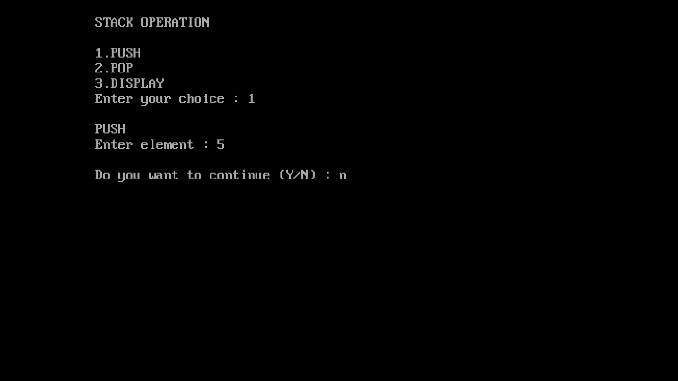
28.
/*Implementation of QUEUE using arrays */
#include<iostream.h>
#include<conio.h>

class QUEUES
{
int QUEUE[30],rear,front;
public:
QUEUES()
{
rear=-1;
front=-1;
}
void PUSH();
void POP();
void DISPLAY();
}q;
void QUEUES::PUSH()
{
int ele;
if(rear==30)
{
cout<<"\n\tQUEUE FULL!";
}
else
{
cout<<"\n\tEnter element : ";
cin>>ele;
QUEUE[rear++]=ele;
}
}
void QUEUES::POP()
{
int ele;
if(rear==-1)
cout<<"\n\tQueue is empty!";
else
{
ele=QUEUE[front];
++front;
cout<<"\n\tElement popped : "<<ele;
}
}
void QUEUES::DISPLAY()
{
int i;
cout<<"\n\tQueue elements : \n\t";
for(i=front;i<=rear-1;i++)
cout<<QUEUE[i]<<" ";
}
void main()
{
clrscr();
char ch='y';
int choice;
do
{
cout<<"\n\tQUEUE OPERATION\n\n\t1.PUSH\n\t2.POP"
<<"\n\t3.DISPLAY\n\tEnter your choice : ";
cin>>choice;
switch(choice)
{
case 1: cout<<"\n\tPUSH";
q.PUSH(); break;
case 2: cout<<"\n\tPOP";
q.POP(); break;
case 3: cout<<"\n\tDISPLAY";
q.DISPLAY(); break;
default:cout<<"\n\tWrong choice!"; break;
}
cout<<"\n\tDo you want to continue (Y/N) : ";
cin>>ch;
}while(ch=='y'||ch=='Y');
getch();
}
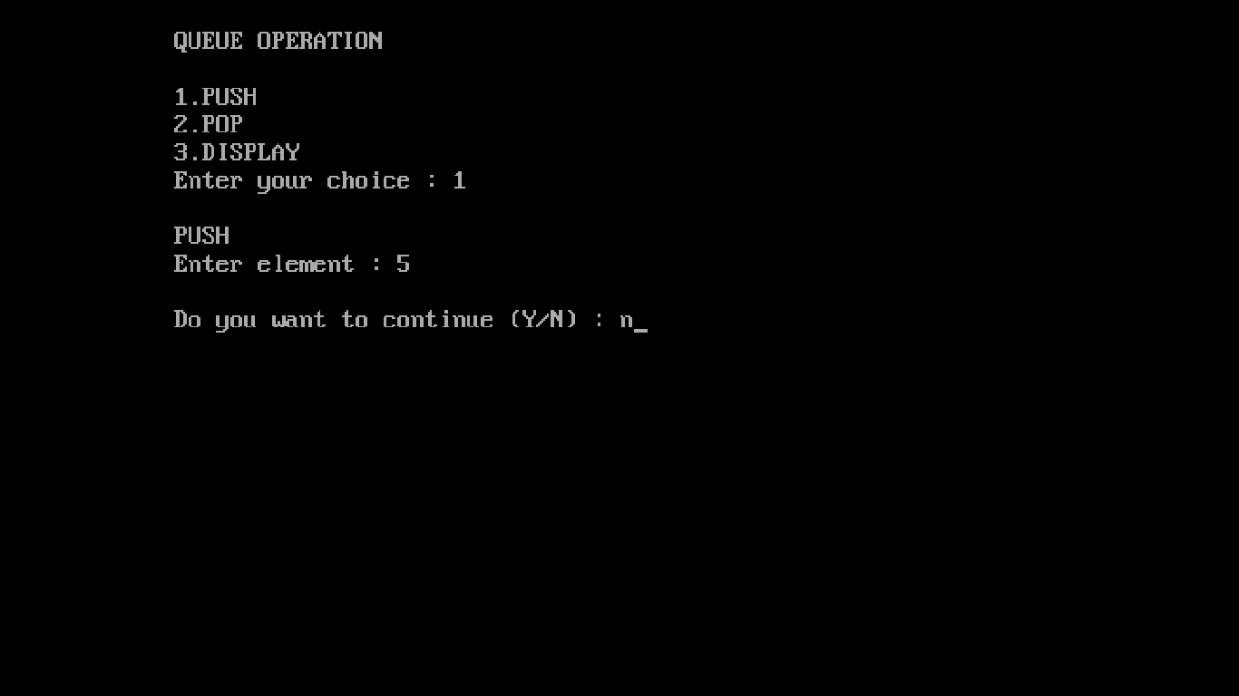
29.
/*Implementation of STACKS using linked lists */
#include<iostream.h>
#include<conio.h>
#include<stdlib.h>

struct Node
{
int RNO;
char Name[30];
Node *link;
}*np,*top;

void PUSH()
{
np=new Node;
cout<<"\n\tEnter RNO:";
cin>>np->RNO;
cout<<"\n\tEnter Name:";
cin>>np->Name;
np->link=NULL;
if(top==NULL)
top=np;
else
{
np->link=top;
top=np;
}
}
void POP()
{
if(top==NULL)
cout<<"\n\tStack is empty!";
else
{
cout<<"\n\tRNO popped:"<<top->RNO
<<"\n\tName popped:"<<top->Name;
top=top->link;
}
}
void DISPLAY()
{
cout<<"\n\tList of elements : \n\t";
for(np=top;np!=NULL;np=np->link)
cout<<np->RNO<<"\n\t"<<np->Name<<"\n\t";
}

void main()
{
clrscr();
int choice;
char ch='y';
do
{
cout<<"\n\tSTACK OPERATIONS\n\n\t1.PUSH\n\t2.POP"
<<"\n\t3.DISPLAY\n\tEnter your choice : ";
cin>>choice;
switch(choice)
{
case 1: cout<<"\n\tPUSH";
PUSH(); break;
case 2: cout<<"\n\tPOP";
POP(); break;
case 3: cout<<"\n\tDISPLAY";
DISPLAY(); break;
default:cerr<<"\n\tWrong choice!"; break;
}
cout<<"\n\tDo you want to continue (y/n) : ";
cin>>ch;
}while(ch=='y'||ch=='Y');
getch();
}
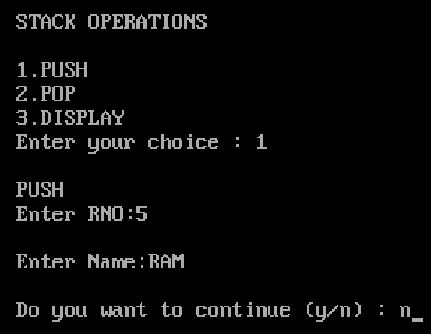
30.
/* Implementation of QUEUE using linked lists */
#include<iostream.h>
#include<conio.h>
#include<stdlib.h>

struct Node
{
int RNO;
char Name[30];
Node *link;
}*np,*rear,*front;

void INSERT()
{
np=new Node;
cout<<"\n\tEnter RNO : ";
cin>>np->RNO;
cout<<"\n\tEnter Name : ";
cin>>np->Name;
np->link=NULL;
if(rear==NULL)
rear=front=np;
else
{
rear->link=np;
rear=np;
}
}
void DELETE()
{
if(front==NULL)
cout<<"\n\tQueue is empty!";
else
{
cout<<"\n\tRNO popped : "<<front->RNO
<<"\n\tName popped : "<<front->Name;
front=front->link;
}
}
void DISPLAY()
{
cout<<"\n\tList of elements : \nt";
for(np=front;np!=NULL;np=np->link)
cout<<np->RNO<<"\n\t"<<np->Name<<"\n\t";
}

void main()
{
clrscr();
int choice;
char ch='y';
rear=front=NULL;
do
{
cout<<"\n\tQUEUE OPERATIONS\n\n\t1.INSERT\n\t2.DELETE"
<<"\n\t3.DISPLAY\n\tEnter your choice : ";
cin>>choice;
switch(choice)
{
case 1: cout<<"\n\tINSERT";
INSERT(); break;
case 2: cout<<"\n\t DELETE";
DELETE(); break;
case 3: cout<<"\n\t DISPLAY";
DISPLAY(); break;
default:cerr<<"\n\tWrong choice!"; break;
}
cout<<"\n\tDo you want to continue (y/n) : ";
cin>>ch;
}while(ch=='y'||ch=='Y');
getch();
}
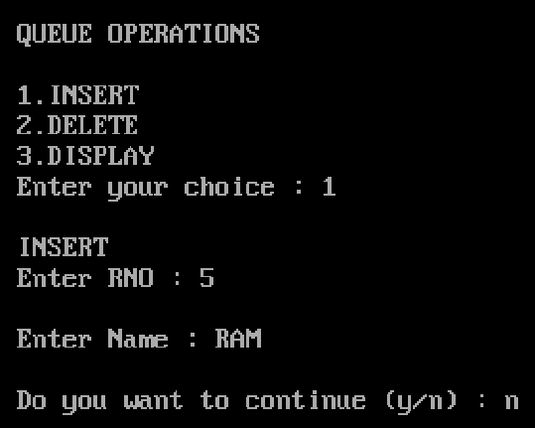
31.
/* vowel words */
#include<fstream.h>
#include<conio.h>

void main()
{
clrscr();
fstream F("text.txt",ios::in|ios::out);
char A[100], word[10];
cout<<"\n\tEnter text: \n\t";
cin.getline(A,100);
F<<A;
F.seekg(0);
cout<<"\n\tVowel words : ";
while(!F.eof())
{
F>>word;
switch(word[0])
{
case 'A': case 'E': case 'I': case 'O': case 'U':
case 'a': case 'e': case 'i': case 'u': cout<<word<<" "; break;
}
}
F.close();
getch();
}
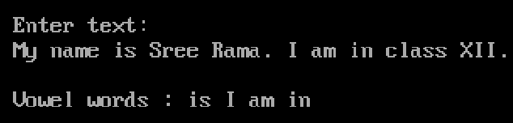
32.
/* count no of : vowels, words, digits */
#include<fstream.h>
#include<conio.h>
#include<ctype.h>

void main()
{
clrscr();
fstream F("text.txt",ios::in|ios::out);
char A[100], ch;
int v=0,w=0,d=0;
cout<<"\n\tEnter text: \n\t";
cin.getline(A,100);
F<<A;
F.seekg(0);
while(!F.eof())
{
F.get(ch);
if(ch==' ')
++w;
else if(isdigit(ch))
++d;
else
switch(ch)
{
case 'A': case 'E': case 'I': case 'O': case 'U':
case 'a': case 'e': case 'i': case 'u': ++v; break;
}
}
cout<<"\n\tNumber of:\n\tWords="<<w<<"\n\tVowels="<<v<<"\n\tDigits="<<d;
F.close();
getch();
}
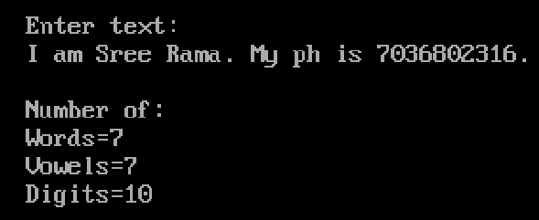
33.
/* replace ' ' with '#' */
#include<fstream.h>
#include<conio.h>

void main()
{
clrscr();
fstream F("text1.txt",ios::in|ios::out);
char A[100],ch;
cout<<"\n\tEnter text: \n\t";
cin.getline(A,100);
F<<A;
F.seekg(0);
fstream f("text2.txt",ios::in|ios::out);
while(!F.eof())
{
F.get(ch);
if(ch==' ')
f.put('#');
else
f.put(ch);
}
f.seekg(0);
cout<<"\n\tUpdated text : \n\t";
while(!f.eof())
{
f.get(ch);
cout<<ch;
}
F.close();
f.close();
getch();
}
